Assignment #9 Neural Networks by Joshua Troup

1. 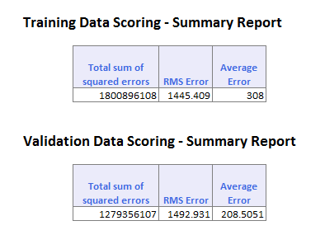

First run of 30 epochs

1. 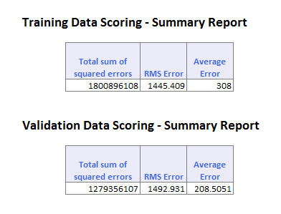

Second run of 300 epochs

1. 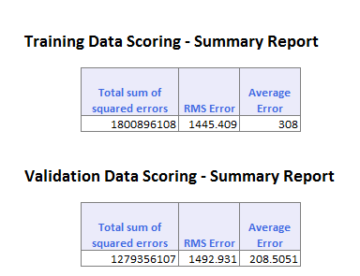

Third run of 3000 epochs

1. 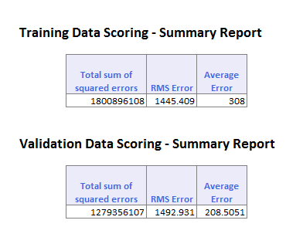

Fourth run of 10,000 epochs

1. The RMS error does not change when the epochs are increased or decreased. There is no pattern or differences between the validation and training sets with different epochs. The model remains the same throughout the epoch variables.
2. The RMS error does not change in validation data when epochs are increased or decreased. The model remains the same as does the training data.
3. The lowest validation RMS error was all the same including 30, 300, 3000, and 10,000 epochs.